Date:28-12-23

DATABRICKS ASSIGNMENT:

Setting up of Azure portal:

* First we have to login into the makemyklabs portal using the login id provided.
* Then connect to the server and generate link.
* Use link and id password to access azure labs.

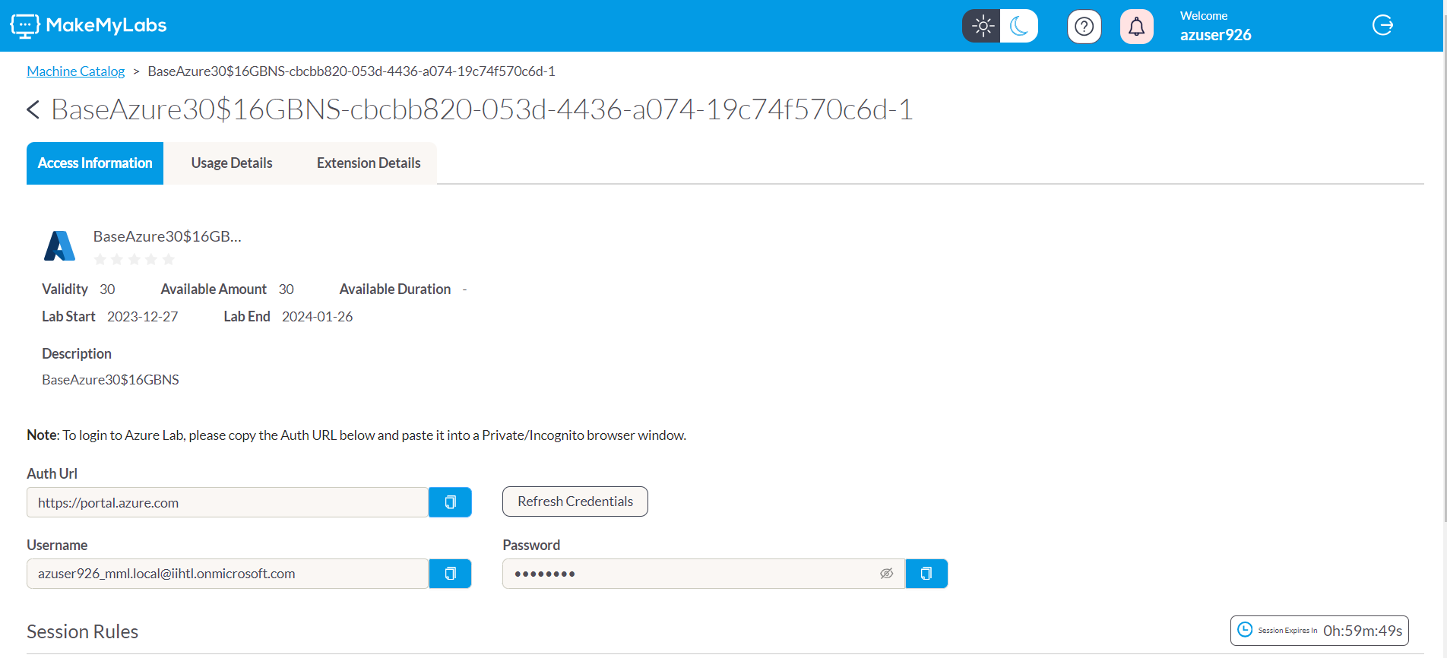

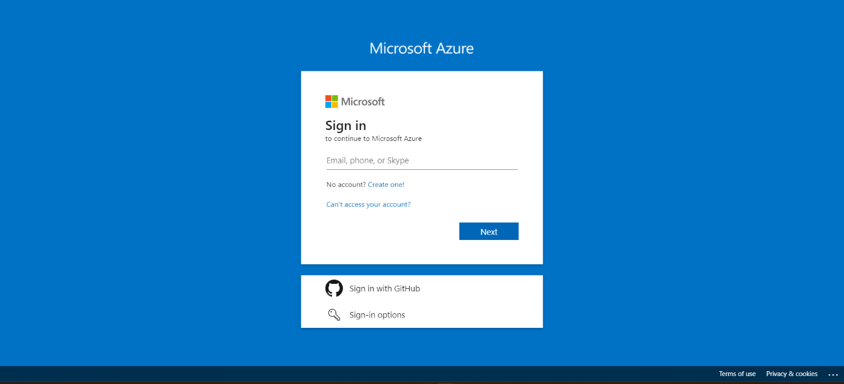

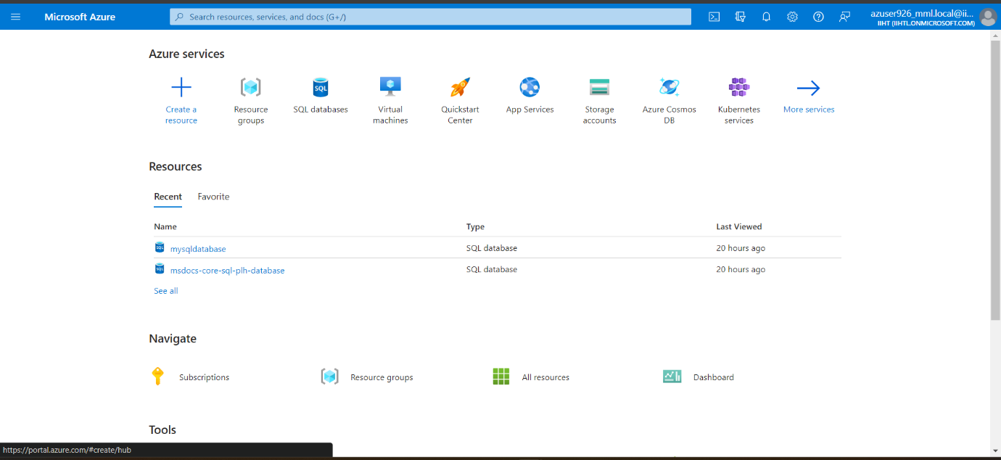

AZURE DATABRICKS:

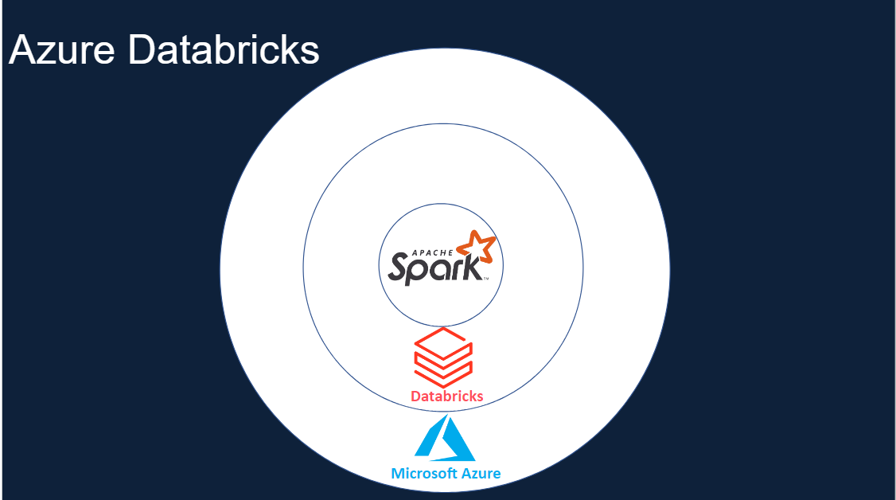

Azure Databricks is a cloud-based analytics platform that helps users create, manage, and deploy big data processing and machine learning workloads.

It's built on Apache Spark and is designed for data science and data engineering.

Azure Databricks provides tools that help you connect your sources of data to one platform to process, store, share, analyse, model, and monetize datasets with solutions from BI to generative AI

APACHE SPARK ARCHITECTURE:

AZURE DATABRICKS ARCHITECTURE:

